H.T No
Regulations:
A18

Sreenidhi Institute of Science and Technology
(An Autonomous Institution)
Code No: 7AC41 Date: 19-Mar-2021(FN)

B.Tech II-Year I- Semester External Examination, March/April-2021 (Regular & Supplementary)
BASIC ELECTRICAL ENGINEERING (CSE and it)

Time: 3 Hours Max.Marks:70

Note: a) No additional answer sheets will be provided.
b) All sub-parts of a question must be answered at one place only, otherwise it will not be valued.
c) Missing data can be assumed suitably.

ANSWER ANY 5 OUT OF 8 QUESTIONS. EACH QUESTION CARRIES 14 MARKS.

Bloom's Cognitive Levels of Learning (BCLL)

Remember | L1 | Apply | L3 | Evaluate | L5
Understand | L2 | Analyze | L4 | Create | L6

 |  |  | BCLL | CO(s) | Marks
1. | a) | State and explain Norton’s theorem. | L1 | CO1 | [7M]
 | b) | Develop Norton’s equivalent circuit across terminals x and y.  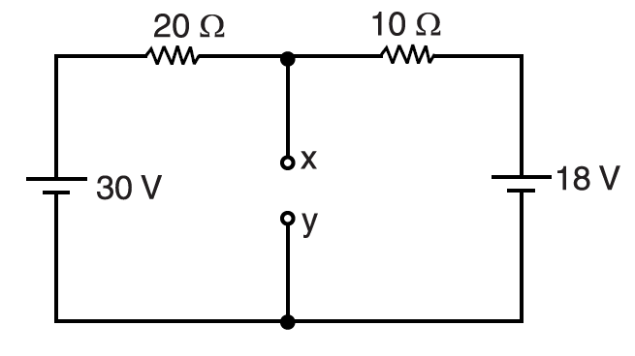 | L4 | CO1 | [7M]
2. | a) | Determine R.M.S value and average value of a Sinusoidal voltage. | L5 | CO2 | [7M]
 | b) | A 230V, 50Hz A.C supply is applied to a coil of 0.06H inductance and 2.5Ω resistance connected in series with a 6.8µF capacitor.  Calculate i) impedance ii) current and iii) power factor. | L3 | CO2 | [7M]
3. | a) | Explain the principle of operation of DC motor. | L2 | CO3 | [7M]
 | b) | Derive EMF equation of D.C generator. | L6 | CO3 | [7M]
4. | a) | Explain construction and principle of operation of transformer. | L2 | CO4 | [7M]
 | b) | Illustrate equivalent circuit of transformer. | L4 | CO4 | [7M]
5. | a) | Derive relation between line and phase quantities of a delta connected three phase system. | L6 | CO5 | [7M]
 | b) | A 3-ϕ, 400V, 50Hz A.C supply is feeding a 3-ϕ delta connected load with each phase having a resistance of 25Ω and a inductance of 0.15H in series. Determine line current and phase current. | L4 | CO5 | [7M]
6. | a) | Explain Construction and working of PMMC type of instrument. | L2 | CO6 | [7M]
 | b) | Differentiate between PMMC and MI instruments. | L4 | CO6 | [7M]
7. | a) | In the below circuit diagram determine Voltage across 4Ω resistor using super position theorem.  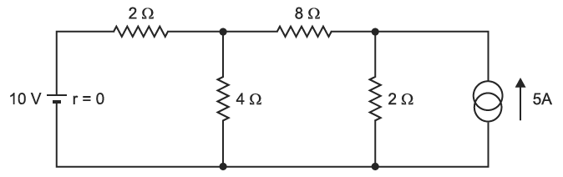 | L5 | CO1 | [5M]
 | b) | Define Active power , reactive power and apparent power. | L2 | CO2 | [5M]
 | c) | Explain how the iron losses can be minimized. | L2 | CO3 | [4M]
8. | a) | A 400/200V single phase transformer is supplied on H.V side with 50Hz A.C supply. Compute the frequency of L.V side output voltage. | L3 | CO4 | [5M]
 | b) | An induction motor is supplied 3-ϕ, 50Hz A.C supply. Compute rotor frequency if it runs at a slip of 0.05. | L3 | CO5 | [5M]
 | c) | Explain different methods of controlling torque of an instrument. | L2 | CO6 | [4M]

-- 00 -- 00 –

